Preparing for MDR | Suggested Retreat Outline

Practical Suggestions
- If possible, go somewhere that is not your usual workplace. You can find lots of suggested places here - https://www.retreats.org.uk/
- Light a candle or have an icon or picture to focus on
- Switch your phone off and tell people in advance that you are not available
- Ask some trusted people to pray for you as you take this time to reflect upon your ministry and vocation and to be with God.

Timings are of course up to you, but it is suggested that you take a day for this retreat. The morning is broken into 3 sections of reflection. We have provided below three possible aids to use these three sections:
- Lectio Divina
- Imaginative contemplation of scripture
- MDR Reflection Aid
If you are used to taking retreats, then please structure the time in a way that you find helpful. You may for instance simply want to be silent.

This timetable is not a straightjacket but a trellis to enable growth. You may well not want to break up your prayer in this way, that’s fine. The main purpose is to create a space to be with God and to reflect on your calling and vocation in his presence.

Suggested timetable
9.00am Prayer to prepare to meet with God (to be prayed slowly)
Direct, O Lord, guide and influence all that is happening in my mind and my heart during this time of prayer...
... all my thinking, longing and fearing
... my moods, feelings and ever changing attitudes
... my remembering, hopes and desires
... my repugnance and resistance
... my sense of depression, boredom, joy or helplessness
Direct and influence all this to your great service and my growth in the Spirit. Amen

9.10am First time of prayer and reflection (using Lectio Divina or Imaginative Contemplation of Scripture)
Possible passages - Isaiah 43:1-5 and/ or Philippians 2:5-11, Mark 10:46-52 (for imagination exercise, any narrative gospel passage)

9.50am Reflect on your time of prayer
- What was it like?
- What words and phrases stayed with you?
- Do you have a sense of the Lord asking anything of you?
- Do you notice any unwillingness to pray?

Prayer: XXXX

10.10am Reflection (use one of the MDR reflection Aids)

11.00 Take a break (go for a walk if it helps)

11.15pm Process Feedback Forms
- What do I feel affirmed by?
- What do I feel challenged by?
- What questions am I left with?
- What have I learnt?
- What might I do in response to these insights?

12.00 noon Midday Prayer with Time to Pray app
App here - https://www.chpublishing.co.uk/apps/time-to-pray
Web here - https://www.churchofengland.org/prayer-and-worship/worship-texts-and-resources/common-worship/daily-prayer/prayer-during-day

12.30 Lunch

1pm Walk or sleep

2pm Fill in Self-Assessment form

3pm Review the whole day
- Thank God for being able to spend time with him and for who he is
- Thank God for your vocation
- Thank God for those areas of your life and work where you are flourishing and bearing fruit
- Thank him for any insights he has given you
- Ask him for courage and strength to work through any challenges or failures that have come to mind
- Ask for forgiveness if necessary
- Use the Examen on p.11 below if helpful
Prayer: XXXX

4pm End

See the following pages for suggested ways to read scripture, reflective tools and ways to pray.

Lectio Divina (Divine Reading)

Lectio Divina is a Latin term, means ‘divine reading’ and describes a way of reading the Scriptures whereby we gradually let go of our own agenda and open ourselves to what God wants to say to us.

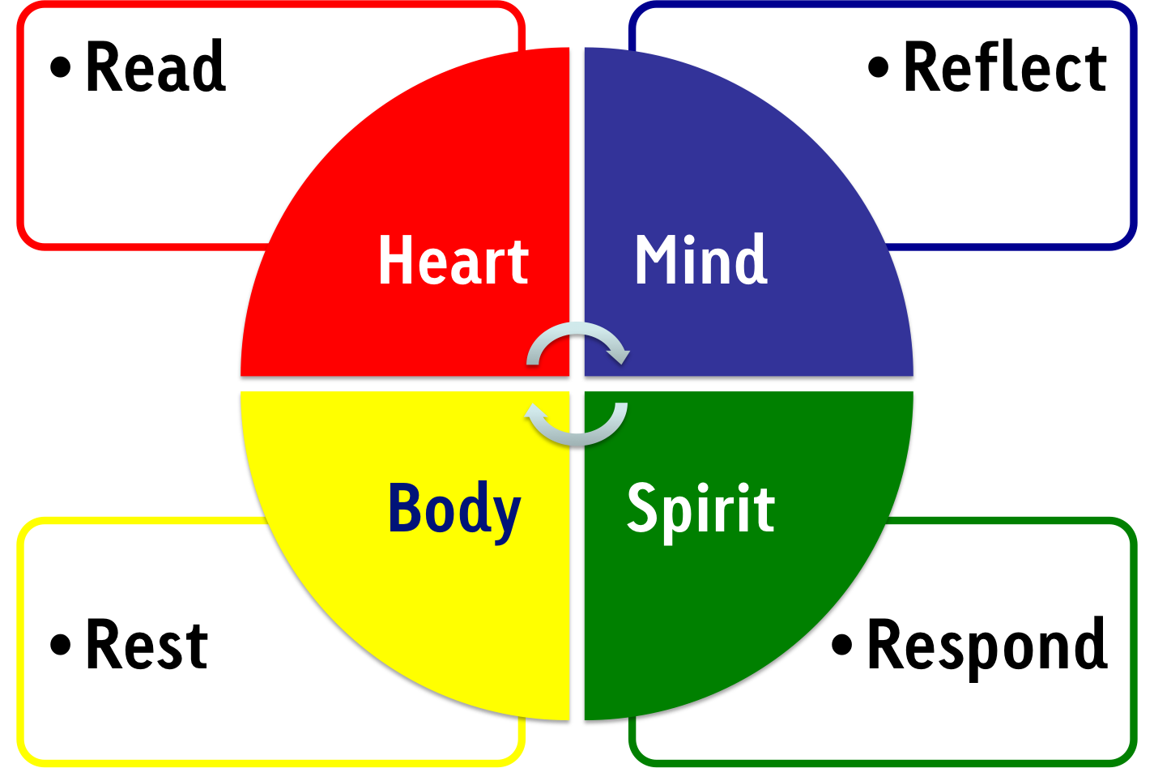

- Read (eat) – we read the Word of God, slowly and reflectively so that it sinks into us. Any passage of Scripture can be used for this way of prayer but the passage should not be too long. Keep reading attentively until a verse/ phrase/ word arrests you. The stop (don’t worry about finishing the text) i.e. what comes alive for you
- Meditate (reflect/ bite a bit off) – where we think about the text we have chosen and ruminate upon it so that we take from it what God wants to give us. It might be a particular word or phrase. Take the word or verse and ‘ponder it in your heart’, repeat it, memorise it, let it speak to you and your hopes, desires, fears. Like sucking a boiled sweet! ‘Tasting the word of God’ (Hebrews 6:5)
- Respond (savour) – where we leave our thinking aside and simply let our hearts speak to God. This response is inspired by our reflection on the Word of God. Offer what you have found and felt to God; talk to him about it; listen to what he has to say about it.
- Contemplate (rest/ digest) – where we let go not only of our own ideas, plans and meditations but also of our holy words and thoughts. We simply rest in the Word of God. We must take what we read in the Word of God into our daily lives. Rest in God’s presence and thank him for what he has said to you.

Imaginative contemplation of scripture

- Read the passage a few times to familiarise yourself with it
- You are in the presence of God, acknowledge this and offer yourself, your time and your imagination to God.
- Ask God for what you need today, what you desire. This could be to for a greater understanding of Jesus, in words such as: Jesus, may I know you clearly, love you more dearly and follow you more nearly. On the other hand it could be something quite different such as 'grant me more patience'.
- Put the passage aside and imagine that the event is happening now. Take time to see in imagination the place, the buildings, countryside etc. What kind of day is it? Feel the breeze or the sun on you; listen to sounds. What is the setting of the story in your imagination? Use touch, taste smell if it helps the scene become more present to you
- Ask yourself who is present; what are they doing; what are they saying? Become a character in the story. Who are you? It may be a central character or someone on the sidelines.
- Let the scene unfold naturally. You may imagine it in the present day, or 2000 years ago. You may find it includes people you know. The story might depart from the gospel scene and take on a life of its own. That’s fine, trust God, everything human is appropriate material for prayer.
Talk to the characters; imagine yourself in conversations by placing yourself in the scene or role playing as one of the characters. Talk to Jesus, participate in the scene. What is Jesus saying to you? What is your response to the questions he asks others in the passage? Talk to him like one good friend to another.
- End with the Lord’s Prayer
- When you have finished, look back over and review the time of prayer.
- See how you reacted and felt.
- Is this saying anything about you, the way you see others or God?
- Did anything surprise you?
- Is there anything that needs healing?
- Is there anything you need to pray about in future?

MDR Reflection Aid
This reflection aid is an optional resource to help you reflect ahead of your MDR review and identify what you might want to bring to the MDR conversation. If you use it, do bring it with you to your MDR meeting.

Three tools to help your reflection

Here are three ways which might be helpful – they are optional - use what works for you.

1 Vocational discernment (after St Ignatius of Loyola)

As I look over my ministry this last few years…

  - What am I most grateful for?

  - What am I least grateful for?

  - Where do I come alive?

  - Where am I diminished?

  - What affirms me in my sense of vocation?

  - What undermines my sense of vocation?

  - What might God be saying to me now?

2. Ministry clock - what does flourishing look like?
This is optional – use if helpful

  - Choose what categories you want to write in the boxes.
  - If 10 is flourishing and 0 is withering, Colour in where you think you are for each segment.
  - Then choose the ones that seem significant and ask yourself ‘what might take me one step further towards flourishing? (Flourishing can be about confidence, resourcing, experience etc.)

The clock below is an example and not meant to be prescriptive – but gives an idea as to what this might look like:

Prayer
School
Pastoral Care
Relationships with colleagues
Preaching
Admin and emails
Safeguarding
Mission
Buildings
Time off/family life

Have a go at the clock below.
Other categories you might want to use could be:
- The workplace
- Voluntary work in the community
- Caring responsibilities
- Chaplaincy
- Discernment about a future post
- Involvement in the wider diocese
- Study
- Relationships with colleagues
- Social media
- Supervising staff
and so on….
My ministry clock - what does flourishing look like for you?
This is optional – use if helpful

3 Checklist This is optional – use if helpful

As you scan down the checklist, ask yourself:
- What is taking a lot of my attention?
- What is taking a lot of my time?
- What causes me anxiety?
- What drains me?
- What gives me energy?
- What do I want to give some time and attention to develop?

- Your primary contexts for ministry

- Other opportunities for engaging in ministry

- Worship – seasons, liturgy and annual cycle

- Occasional offices

- New services/initiatives

- Sermon and teaching

- Prayer and spirituality

- Church family life

- Mission opportunities

- Safeguarding

- Institutions in the parish – schools, hospitals, and so on

- Church presence locally

- Administration, diary management, IT, office

- Parish planning

- Deanery or other roles, meetings, chapters etc

Using our Senses
Focus on what you can smell, touch, hear, feel and taste. Seek to be more aware of God through your senses.

Think about how God comes to us in our memory, our understanding and our will (sometimes called the three powers of the soul)

Memory in the sense of 'bringing to mind' or awareness of what is; The human quality is that we can remember things, we can learn from the past.

Understanding: once we have become of aware of what is, we can judge what is good and healthy, what is right and consoling for us. We can understand ourselves and others better.

Will: Finally, we can decide what to do. After having brought to mind what has gone on around us, and within us, after having understood motivations, what is good and what is not, I can then decide to act upon what I have learned using my will.

The Examen
One of the ways God speaks to us is through our deepest feelings and yearnings, what Ignatius of Loyola (1491 - 1556) called “consolation” and “desolation.”

Consolations are those experiences that fill us with joy, life, energy and peace.

Desolations are those that drain us and feel like death.
Consolations connect us with ourselves, others and God.

Desolations disconnect us. The questions below are one simple way of discovering the day’s consolation and desolation, that is, the interior movements of God through which He is speaking and leading. Use this powerful tool each day‐‐ perhaps before you go to bed, at a meal with others, as part of a Daily Office or Sabbath, or even on a holiday such as New Year’s or Christmas.

Take about two to three minutes of silence, becoming aware of God’s presence. As you do so, ask yourself these two questions:

1. When did I feel most alive this week?
2. When did I most feel life draining out of me?

Another way to ask the same question might be:
1. For what moments this week am I most grateful?
2. For what moments this week am I least grateful?

End with prayer for grace to be more aware of God’s presence and leadings.

